Learning Management System
- Emotion Recognition

Introduction

Learning management System (LMS) is one of the basic needs for the professionals and as well as students who wants to enhance their skills in today’s changing world. During the pandemic of 2022 i.e. Covid-19 where every individuals were locked inside their home- these learning platforms emerges like a pro players in education sector and as well as for the professionals. We were astonished when the news published that one individuals from Chennai, India has completed almost 200+ degree programs from LMS. LMS is same as schools or colleges for professional and students where they can acquire new skills in this changing world.

LMS provide the feasibility of choice of time i.e. generally LMS has pre-recorded session which the user can see as per their own schedules sometimes LMS also has live session if users want to attend the live session they can attend but LMS give them option to go through the live session as per their schedules also. In all business platform user feed back is one of the most crucial activities – it helps the organisation to make the product more use friendly, effecting and appealing to the users. Traditional user feedback system includes rating the platform, performing surveys and many other type of the procedures. But from my experience, none of the existing pioneers LMS platforms like Udemy, Courcera or Indian built edtech platforms like Great Learning, or even Byju’s. In our platform, we have integrated the Emotion Recognition Module which will act as a user feedback system in our system along with the traditional user feed back system.

Emotion Recognition Module integrated in our system will enable us to kill two birds with one stone i.e. we will be able
to get the real time feed back from the user or participants on the instructors as well as we will able to analyse the effectiveness of of course detail, delivery and the understanding of the user. So we can further improve the LMS by benchmarking the live user feedback also we will generate our own dataset i.e. to make emotion recognition module more robust.

1. Architecture Diagram

As explained above in the Introduction section about the benefits of integrating the Emotion Recognition Module in our LMS, let discuss about the architecture of this module. The architecture of the module is pretty simple to implement but it is composed of various sub modules which make the system robust.
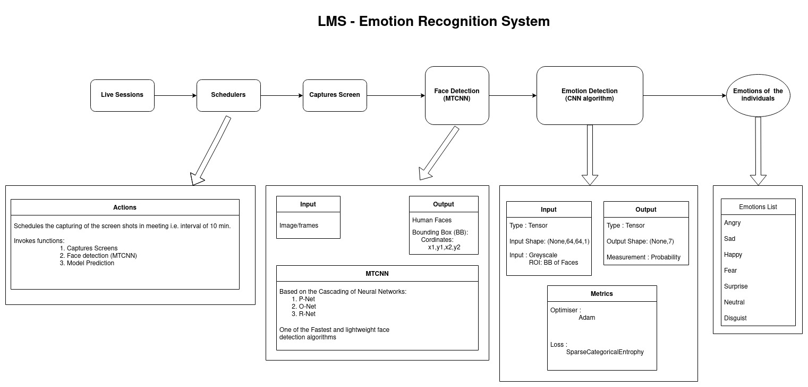Figure 1: Emotion Recognition Module Architecture

The module is composed of schedulers which will capture the screen at specific intervals which will depends on the meeting/class duration suppose the meeting is of 60 minutes then the module will capture the screen at an interval of 20 minutes. The captured screen is then sent as an input to the Face detection algorithm i.e. Mtcnn – whose sole purpose is to detect the faces from the captured screen ape output the bounding box i.e. the co-ordinate of the faces. After the detection of the faces in the captured screen the region of the interest i.e. face is extracted from and it is sent to the emotion recognition module which predicts the emotions of the faces detected.

1.1. Schedulers

In, this module the schedulers act as the triggers to activate the whole model, it accepts

